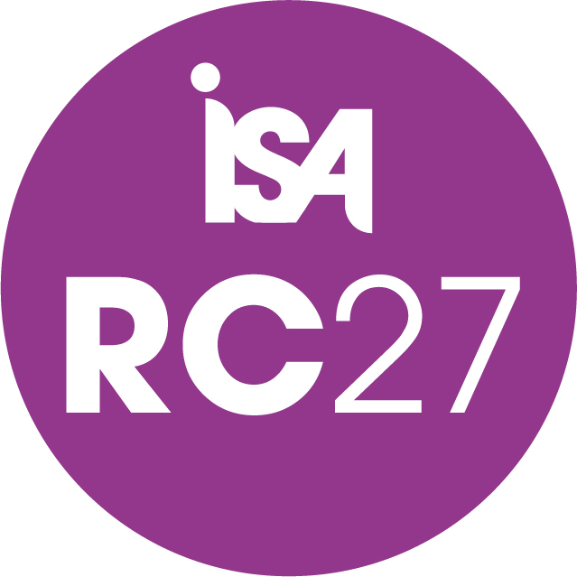 | The XXI International Sociological Association World Congress of Sociology will be held from 4 to 10 July 2027 in Gwangju, South Korea. The Congress theme is “Global Sociology in Turbulent Times”  - We invite proposals for Sessions for RC27 (Sociology of Sport.  - For detailed information, refer to the link https://www.isa-sociology.org/en/conferences/world-congress/gwangju-2027/xxi-isa-congress-theme)
The Call for Sessions for RC27 will close on June 25, 2026, at 23:59 UTC/GMT.  - The link is available here: https://isaconf.confex.com/isaconf/wc2027/cfs.cgi | - The Call for Sessions link will take you to the Session Control Panel, where steps to propose a session for the RC27 Sociology of Sport in the Conference System are available. Please refer to the detailed information for the session proposal below (the relevant link is available at https://www.isa-sociology.org/en/conferences/world-congress/gwangju-2027/xxi-isa-congress-guidelines/duties-deadlines-27/xxi-isa-congress-timeline-cfs)

Call for Sessions for RC27


Notes for Session Organisers
